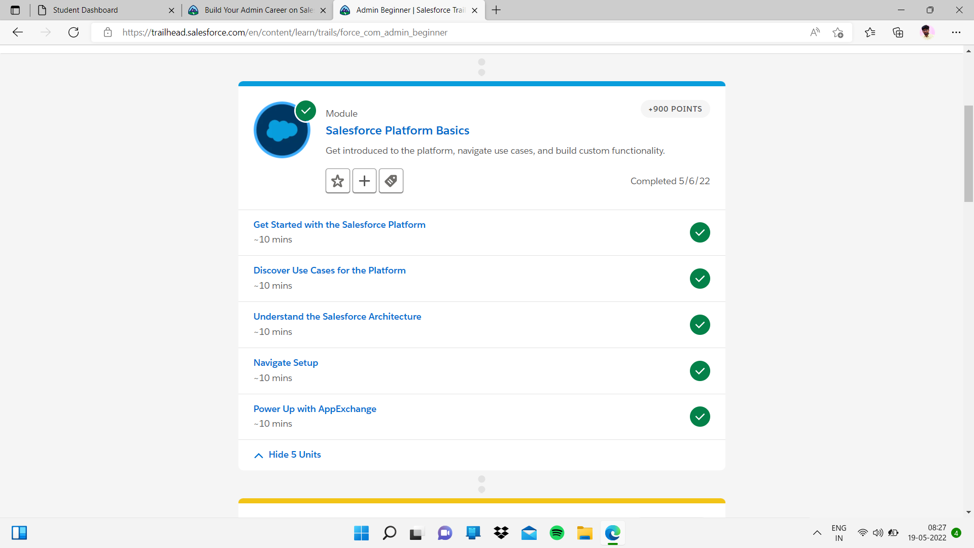

sub Topic:- Discover Use Cases for the Platform

in this topic I completed quiz

